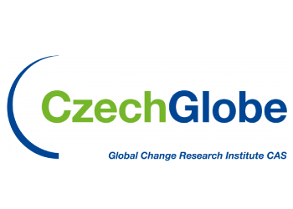
Study in Europe,
study in Czech Rep.

The Global Change Research Institute of the Czech Academy of Sciences - CzechGlobe
seeks highly motivated candidates for a PhD study with focus
on the analysis of ecosystem-atmosphere greenhouse gas exchange
The Department of Matters and Energy Fluxes operates a set of ecosystem stations across the Czech Republic (Middle Europe) and is operating ecosystems stations in tropical areas including Vietnam. All the stations are equipped with state-of-the-art measurement systems (eddy-covariance technique, meteorological sensors, soil sensors). The department cooperates with research institutes and universities across Europe and out of Europe (USA, Vietnam, Ghana and others).
Project and tasks
A successful candidate will obtain a contract with CzechGlobe and will learn methods for investigating greenhouse gas exchange on the ecosystem level. Study subjects are fluxes of greenhouse gases (CO₂, CH₄) derived with eddy-covariance and chamber measurements, meteorological data, partly biomass inventory data and remote sensing data. The main task will be to learn the eddy-covariance method including analysing and interpreting matters and energy fluxes exchanged between the ecosystem and the atmosphere. Subsequent publishing of the results in international scientific journals is expected. More specific study and research goals can be defined in the course of the studies in agreement with the suitable candidate. After a successful defence of the PhD thesis, the graduate can become a member of the new research team in VNU Ho Chi Minh City – University of Science – Vietnam.
We require:
- Distinct interest in the project and tasks,M.Sc. degree in biological, environmental or atmospheric sciences
- Basic knowledge in statistical analysis
- Enthusiasm to write scientific papers
- Good written/spoken English communication skills
- Ability to work collaboratively with an interdisciplinary team of scientists
We offer:
- Creative scientific work, self-realization
- Ability to use data from an excellent research infrastructure
- Possibility of personal career and scientific growth
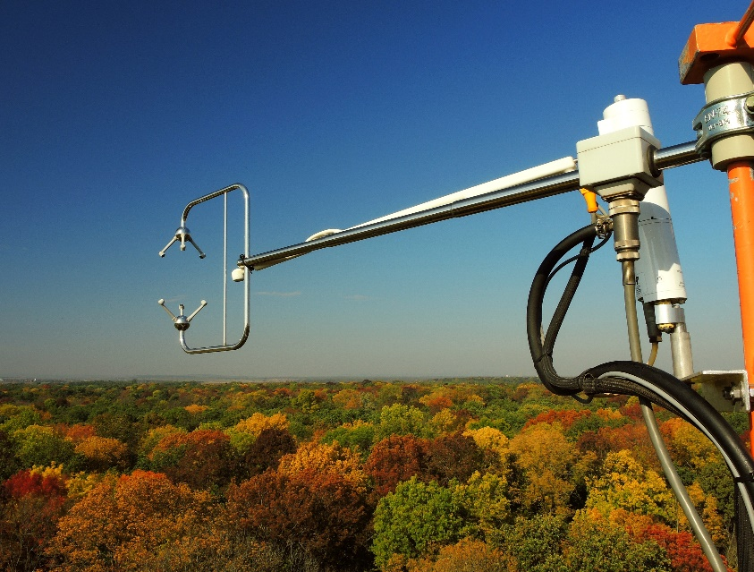
- Work in an international team
- Contract with appropriate salary
Further information about the position:
Marian Pavelka, Ph.D.
Head of Dept. of Matters and Energy Fluxes
Global Change Research Institute
pavelka.m@czechglobe.cz
www.czechglobe.cz/en/
The deadline for applications is 31 May 2021.
Please send a motivation letter and structured CV
to jobs@czechglobe.cz,
write “eddy covariance student” to the subject.

